Week 4 Internship Documentation
Infosys Springboard Internship | Data Visualization Domain
Topic Focus: Dataset Understanding, Profiling, KPI Selection, and Dashboard Planning
Prepared by: Prabhakar Kumar Shahi
Project: Optimizing IT Support Team Performance Using Analytics


1. Introduction
During Week 4 of the internship, the focus shifted from learning Power BI and Power Query concepts to working directly with the actual project dataset. This week was highly important because it connected the dataset structure with the business problem statement. The main activities included understanding the dataset in depth, profiling the data, identifying cleaning requirements, selecting relevant KPIs, and planning the dashboard design for the project titled 'Optimizing IT Support Team Performance Using Analytics.'
This week represents the transition from technical learning to business-driven analytics. Instead of only learning tools, the work was now focused on how the dataset can answer real business questions and support better decision-making for an IT support team.

2. Dataset Introduction
The dataset used in this project is a customer support / IT support ticket dataset. Each row in the dataset represents a single support ticket raised by a customer. The dataset contains a combination of operational, customer, technical, and service quality information. This makes it highly suitable for performance analysis because it allows the support process to be studied from multiple perspectives such as ticket volume, response time, resolution time, escalation behavior, SLA compliance, and customer satisfaction.
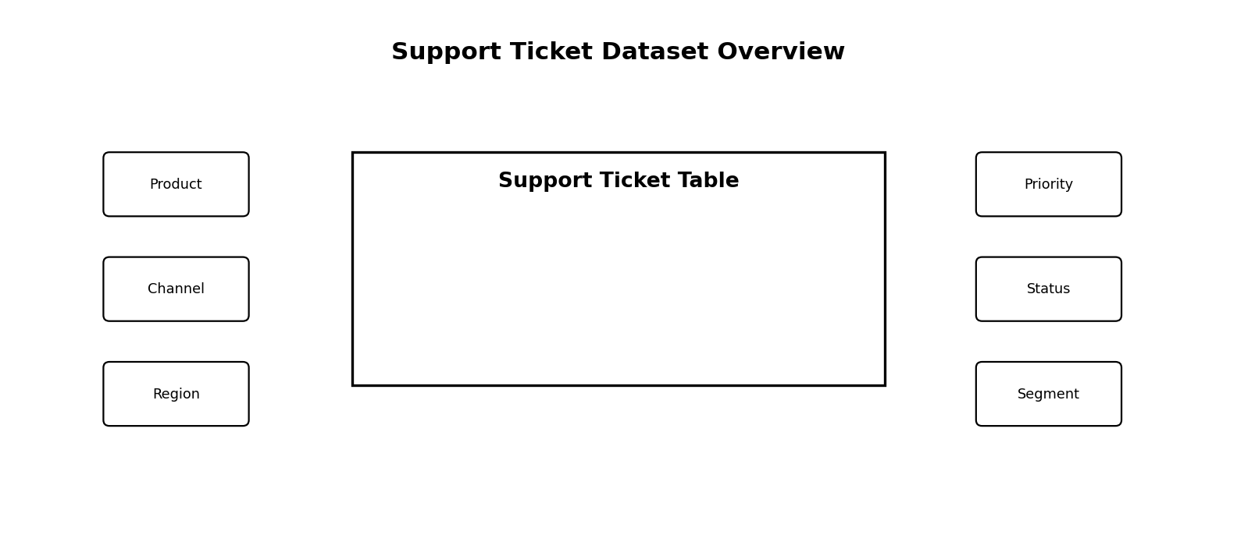
Figure 1: Illustrative view of the support ticket dataset and its major analysis dimensions

3. Dataset Column Understanding (Data Dictionary)
Column Name | Meaning / Business Use
ticket_id | Unique identifier for each support ticket
customer_name | Name of the customer who raised the ticket
customer_email | Customer contact email
product | Product or service associated with the issue
category | Type of issue such as performance issue or account suspension
issue_description | Detailed description of the problem reported by the customer
resolution_notes | Notes describing how the issue was handled or resolved
priority | Urgency level of the ticket such as Medium, High, or Urgent
status | Current status of the ticket such as Open, Closed, or Pending Customer
channel | Support channel used by the customer
region | Geographic region of the customer
customer_age | Age of the customer
customer_gender | Gender of the customer
subscription_type | Subscription plan such as Free, Premium, or Enterprise
customer_tenure_months | Months the customer has used the service
previous_tickets | Number of earlier tickets raised by the same customer
customer_satisfaction_score | Customer rating after support interaction
first_response_time_hours | Hours taken to first respond
resolution_time_hours | Hours taken to resolve the ticket
ticket_created_date | Ticket creation date
ticket_resolved_date | Ticket resolution date
escalated | Whether the ticket was escalated
sla_breached | Whether the SLA was breached
operating_system | Customer operating system
browser | Browser used by the customer
payment_method | Payment method
language | Preferred language
preferred_contact_time | Preferred time for contact
issue_complexity_score | Numeric issue complexity
customer_segment | Segment such as Small Business or Corporate

4. Understanding the Dataset More Deeply
This dataset is a multi-dimensional business dataset. It combines ticket performance metrics, customer profile information, technical environment details, and customer experience indicators. Because of this structure, it can support descriptive, diagnostic, and operational analytics.
- Ticket Performance Layer: priority, status, escalated, sla_breached, first_response_time_hours, resolution_time_hours
- Customer Layer: age, gender, subscription type, tenure, previous tickets, customer segment
- Technical Layer: product, operating system, browser, payment method
- Experience Layer: satisfaction score, preferred contact time, channel, language
- Issue Layer: category, issue description, resolution notes, complexity score

5. Data Profiling
Before building the dashboard, the dataset must be profiled. Data profiling means examining the structure, quality, consistency, and distribution of the data before final cleaning or visualization.
- Check total rows and columns
- Check uniqueness of ticket_id
- Inspect null values in important columns
- Verify correct data types
- Check distinct values in categorical columns
- Identify outliers in response and resolution times
- Validate logical consistency between status and resolved date

6. Cleaning the Actual Support Ticket Dataset

6.1 Data Type Conversion
Column | Recommended Data Type
ticket_id | Whole Number or Text
customer_age | Whole Number
customer_tenure_months | Whole Number
previous_tickets | Whole Number
customer_satisfaction_score | Whole Number / Decimal
first_response_time_hours | Decimal Number
resolution_time_hours | Decimal Number
issue_complexity_score | Whole Number
ticket_created_date | Date
ticket_resolved_date | Date

6.2 Standardization of Categorical Columns
- Standardize priority, status, channel, and region values
- Standardize Yes/No values in escalated and sla_breached
- Convert browser value 'N/A' to 'Unknown'
- Ensure customer_gender values are consistent
- Standardize subscription_type and customer_segment labels

6.3 Null Handling
- resolution_notes: replace null with 'Not Provided' if required
- browser: replace null or N/A with 'Unknown'
- ticket_resolved_date: keep blank for unresolved tickets
- resolution_time_hours: keep blank for unresolved tickets
- customer_satisfaction_score: use mean or median only if business logic allows

6.4 Duplicate and Logic Validation
- Check and remove duplicate ticket_id values
- If status is Closed, ticket_resolved_date should normally exist
- If status is Open, resolution_time_hours may be blank
- Response and resolution times should not be negative

7. KPI Selection Based on the Actual Dataset
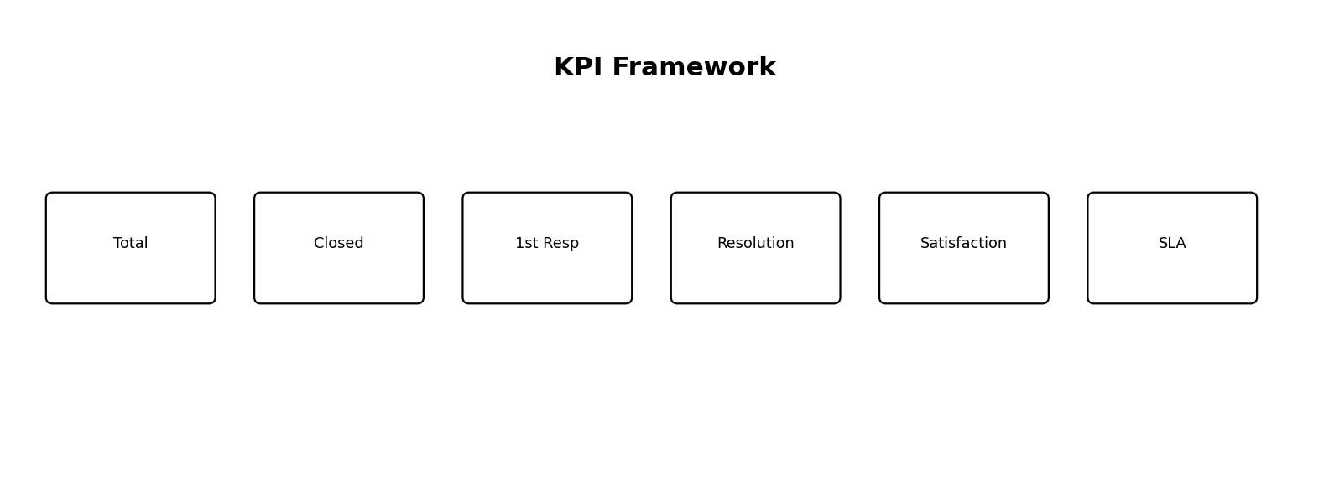
Figure 2: Illustrative KPI framework selected for the Week 4 dashboard
KPI | Business Purpose
Total Tickets | Measures overall support workload
Closed Tickets | Measures completed support cases
Open Tickets | Measures active or pending workload
Resolution Rate | Shows percentage of tickets completed
Average First Response Time | Measures response efficiency
Average Resolution Time | Measures issue-solving efficiency
Average Customer Satisfaction Score | Measures service quality
Escalation Rate | Shows how often tickets require higher-level support
SLA Breach Rate | Measures service-level compliance issues
Urgent Ticket Count | Highlights critical workload pressure

8. Dashboard Planning
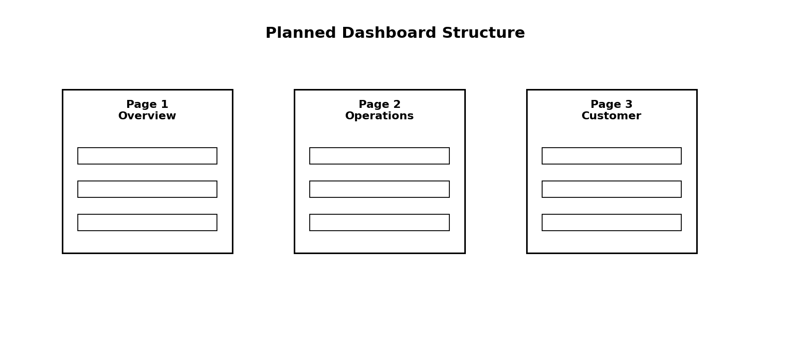
Figure 3: Planned dashboard structure divided into three major pages

8.1 Page 1 – Executive Overview
- KPI Cards: Total Tickets, Closed Tickets, Avg First Response Time, Avg Resolution Time, Avg Satisfaction, SLA Breach Rate
- Line chart for ticket volume over time
- Donut chart for ticket status distribution
- Bar chart for tickets by priority
- Bar chart for tickets by region

8.2 Page 2 – Operational Performance Analysis
- Bar chart: category vs ticket count
- Bar chart: product vs ticket count
- Column chart: priority vs average resolution time
- Column chart: channel vs average first response time
- Stacked chart: escalated vs non-escalated by category

8.3 Page 3 – Customer Experience and Segment Analysis
- Bar chart: customer segment vs average satisfaction
- Bar chart: subscription type vs average resolution time
- Scatter plot: resolution time vs satisfaction
- Column chart: preferred contact time vs ticket count
- Bar chart: issue complexity score vs average resolution time

9. Problem Statement Mapping to Visuals
Business Problem | Relevant Columns | Suggested Visual
Unresolved or pending tickets | status | Donut chart and KPI card
Slow first response | first_response_time_hours, channel | KPI + column chart
Long resolution time | resolution_time_hours, priority | KPI + comparison chart
SLA breaches | sla_breached, region, category | KPI + bar chart
Too many escalations | escalated, category | Stacked bar chart
Low customer satisfaction | customer_satisfaction_score | KPI + scatter plot

10. Business Questions Answered by the Dashboard
- How many total support tickets are being raised?
- What percentage of tickets are Open, Closed, or Pending Customer?
- Which categories generate the highest number of support tickets?
- Which products create the greatest support burden?
- What is the average first response time of the support team?
- What is the average resolution time for tickets?
- Which ticket priorities take the longest to resolve?
- What percentage of tickets breach SLA?
- Which support channels are fastest and slowest in response?
- Which regions face more delays or escalations?
- Does issue complexity increase resolution time?

11. Expected Insights from the Dataset
- Urgent tickets may still experience high resolution time
- Certain products may generate repeated performance-related issues
- Some support channels may have slower first response times than others
- Higher issue complexity scores may correlate with longer resolution times
- Escalated tickets may have a higher probability of SLA breach
- Customer satisfaction may decline when response and resolution times increase

12. Why Week 4 Is Important in the Internship
- The actual dataset was understood in depth
- Data profiling identified the quality and structure of the dataset
- Cleaning requirements were planned based on real columns
- Relevant KPIs were selected for the dashboard
- Business questions were identified for decision-making
- The problem statement was mapped directly to Power BI visuals

13. Week 4 Learning Summary
In Week 4, the internship work became more project-specific and business-oriented. The actual support ticket dataset was explored in detail, and each column was studied for its analytical relevance. Data profiling was performed to identify quality issues, data types, and possible inconsistencies. Based on the structure of the dataset, cleaning requirements were defined and KPI selection was completed. A multi-page dashboard structure was also planned so that the final Power BI report can answer key business questions related to response efficiency, resolution efficiency, SLA compliance, escalation behavior, and customer satisfaction.

14. Conclusion
Week 4 was one of the most important stages of the internship because it directly connected the dataset to the business goal of the project. By understanding the actual support ticket dataset in depth, profiling the data, planning the cleaning strategy, selecting meaningful KPIs, and designing the dashboard structure, the project moved from learning mode into solution-building mode. This week provides a strong foundation for the upcoming stages of Power BI dashboard development and business insight generation.

